Media Contacts

Katie Sikorski
katiesikorski@lmo.com

Jordan Washington
jordanwashington@lmo.com

Bosch Bluehound Asset Management System Brings Inventory Transparency to the Jobsite

MOUNT PROSPECT, Ill. – October 15, 2020 – Robert Bosch Power Tools GmbH, a division of the Robert Bosch Group, enhances inventory management with Bosch Bluehound, a Bluetooth® tag-based asset management system that can be applied to virtually any construction site asset, from a truck down to the smallest drill.

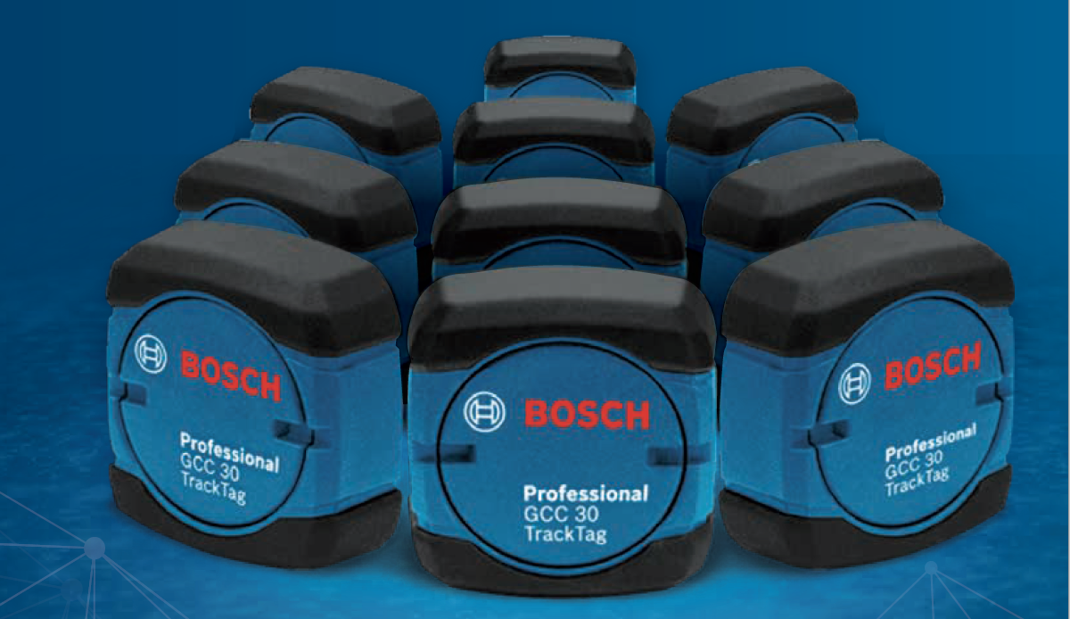

Bosch combines connectivity, engineering and the cloud to enable real-time asset tracking from the warehouse to the jobsite and everywhere in between. Designed with the large contractor in mind, Bluehound collects actionable data that construction firms can use to improve planning, coordination, compliance and personnel training.

The Bluehound system was developed using direct feedback from construction firm owners, yard managers, technology officers, operations managers and everyone in between. The system’s solutions-based features include:
- Asset delivery tracking from warehouse to jobsite with available notifications when the product arrives
- End-of-day asset tracking
- The ability to easily trace any asset — no matter the brand — via serial number, inventory number, model number, warranty information, etc.
- Maintenance alerts and updates to keep track of safety equipment and scheduled asset maintenance
- Asset assignment to jobsite, job box, warehouse and individuals for complete transparency to where a tool is assigned
- Employee certification storage
- Document storage linked to an asset

Bluehound is an open system that allows users to log and track thousands of assets and can be used with any brand tool, not only Bosch products. Assets can be tagged with Bluetooth modules GCC30-4, which are mounted on power tools and other work equipment. Bluehound seamlessly integrates with the GCY42 connectivity module on connected-ready Bosch tools.

The Bluehound system eliminates the drain on time and resources caused by extended wait times for tools and materials. Users can quickly see the location, location history and operational status of any tagged asset. With the ability to store safety certifications and other documentation for assets, Bluehound can help safety managers confirm compliance with OSHA regulations without causing delays. The system also helps to decrease unnecessary expenditures that come with maintaining non-utilized or under-utilized tools.

The system gives users the ability to notify workers when assets assigned to them are left behind at the warehouse or jobsite in real-time, further increasing accountability and loss prevention. Plus, Bluehound consolidates site data in order to manage tools that are used on individual job sites. The system gives users increased access to up-to-date information, helping to improve both costs and bid accuracy.

“We developed Bluehound taking into consideration every crew member on a large construction site,” explains Tammy Bauer, pro user marketing manager and Bluehound business owner, Bosch. “We sought to streamline asset management and simplify tracking for everyone involved and to create a more connected jobsite. Thus far, we’ve seen promising results with contractors commenting on ease of use as well as the application’s mobile-friendly interface and useful data tracking.”

Bluehound uses a subscription-based pricing model, a tiered monthly contract that corresponds to the amount of Bluetooth tags a company uses for tracking assets, inclusive of software and replacement tags.

To learn more about the Bosch Bluehound asset management system, visit www.boschbluehound.com.
# # #

About Bosch Bluehound
Bluehound is an asset management system developed by Robert Bosch Power Tools GmbH, a division of the Robert Bosch Group, one of the world’s leading providers of power tools, power tool accessories and measuring tools. Bluehound, based in Mount Prospect, Illinois, is a cloud-based asset management and tracking solution, designed to boost productivity and transparency from warehouse to jobsite. Through the web portal and mobile application, users can track, manage and localize work assets at any time.

Visit www.boschbluehound.com for more information. Follow Bosch Power Tools North America on Facebook, Twitter and Instagram.

About Robert Bosch Tool Corporation
Robert Bosch Tool Corporation, the Power Tools Division of North America, was formed in January 2003 when Robert Bosch GmbH combined its North American diverse power tool and accessories businesses into one organization. As a manufacturing pioneer with more than a century’s worth of experience, the Bosch name has become synonymous with engineering excellence. Located throughout North America as part of the global power tools division, Bosch associates maintain a legacy of world-class design, manufacture and sale for power tools, rotary and oscillating tools, accessories and measuring tools. For more information, call toll-free 877-BOSCH-99 (877-267-2499) or visit www.boschtools.com

BOSBH/1020/01

