Media Contacts

Katie Sikorski
katiesikorski@lmo.com

Jordan Washington
jordanwashington@lmo.com

Introducing RefinemySite by Bosch
Software for digitizing Lean construction planning and collaboration

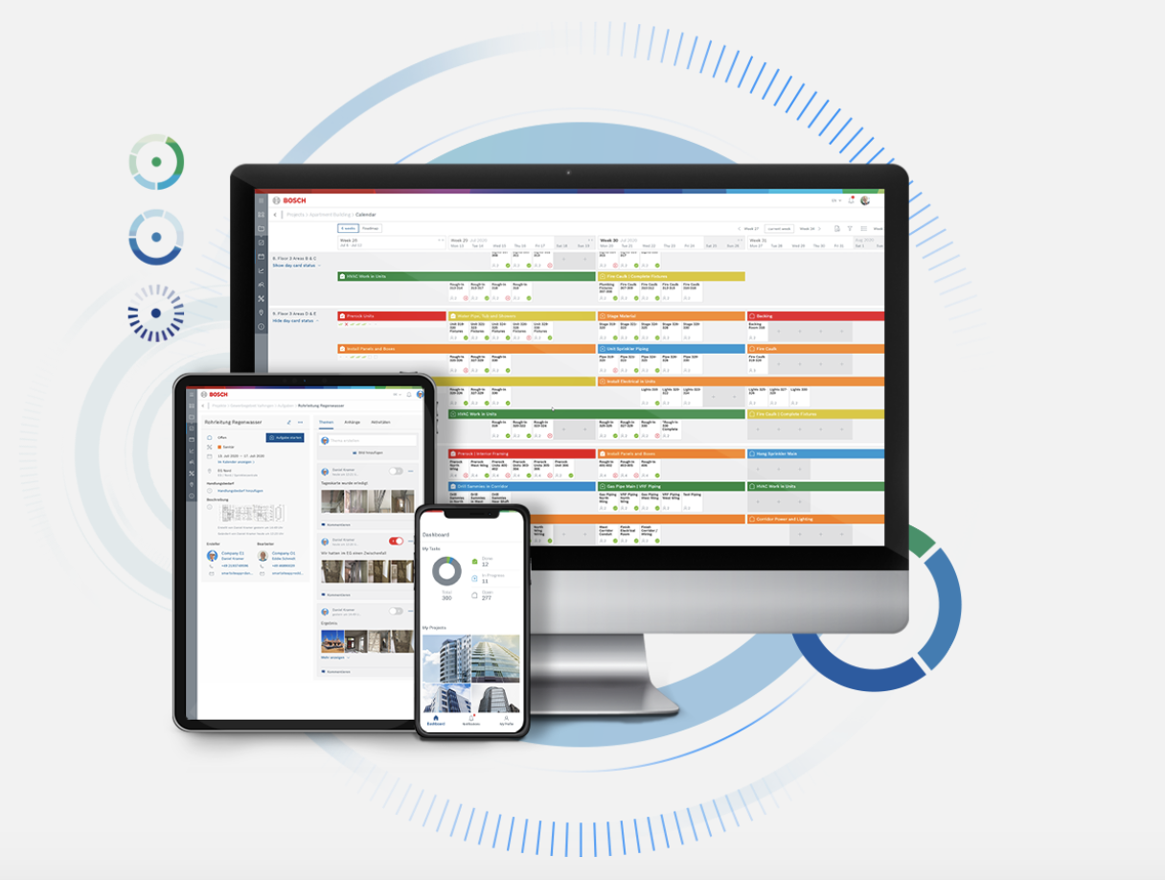
MOUNT PROSPECT, Ill. – October 5, 2020 – Robert Bosch Power Tools GmbH, a division of the Robert Bosch Group, is pleased to unveil RefinemySite, an easy-to-use, digital construction site platform that allows teams to plan, communicate and document jobsite changes in real-time.

Using Lean management principles as a guide, the cloud-based software improves work visibility, communication and collaboration to increase jobsite productivity. RefinemySite by Bosch helps construction firms efficiently utilize Lean Construction Institute’s (LCI) Last Planner System® by digitizing and documenting workflow components:
- Process Analysis: clarify the logic behind plans and structures with input from all participating team members
- Milestone Planning: define and clarify goals every week for each phase of the project
- 6-Weeks Look-Ahead: makes tasks ready with constraint indicators visible to all team members
- Daily Huddles and Weekly Planning: prepare, review and coordinate work between trades through day cards that add greater clarity of workflow
- Continuous Improvement: review task planning reliability, clearly identifying areas of improvement that will support project success

Lean management principles improve productivity by valuing people and empowering team members to optimize processes and eliminate inefficiencies. Bosch understands the value of team collaboration and maintaining optimal process efficiency and incorporates that thinking into RefinemySite software.

With RefinemySite, the project information traditionally captured on sticky notes and whiteboards becomes easily accessible via the cloud platform on computers and smart devices to all team members in real-time from any location.

Through one-time registration, the lean construction platform with an intuitive and user-friendly design gives site managers and trade contractors a welcome tool for real-time updates. Structured similarly to popular social media platforms, RefinemySite empowers those who perform the work to share in the planning of the work.

RefinemySite makes jobsites more attractive to trade contractors by giving them clear information to help reduce common pain points like trade stacking, unavailable equipment, unreliable material deliveries and incorrect time estimates. This easy-to-use and dynamic digital Lean tool encourages everyone onsite to contribute to a project’s outlined goals and keeps meetings concise and action-oriented.

The Utility Connect Project recently simulated the use of the platform on a Clayco construction project. The result? With RefinemySite to improve real-time collaboration and communication, the project could have saved $300,000 to $500,000 in labor and direct costs. These findings align with the results construction firms across the United States and Europe have realized by implementing RefinemySite.

“The impetus behind developing RefinemySite was to create a digital complement to traditional Lean practices that improves communication, accountability and insight across every phase of a project,” explains Rafael Franca, head of business RefinemySite North America, Robert Bosch Tool Corporation. “It’s what we’ve learned today’s leaders are looking for. A 2018 report by EY that surveyed 80+ leading construction and engineering companies found that 98 percent of respondents agreed that digital solutions will be critical to the future of their companies. RefinemySite by Bosch is made to fit that mold and customers such as Bycor General Contractors, Clayco, Fluor, Gilbane, Okland Construction and Whiting-Turner, and many others in North America and Europe, are already seeing results. Over the past 12 months, 300 projects have tested and approved RefinemySite by Bosch.”

To learn more about RefinemySite by Bosch, visit bosch-refinemysite.us or the official RefinemySite LinkedIn page.

# # #

About RefinemySite by Bosch
First conceptualized in 2017, RefinemySite by Bosch is an internal startup from Robert Bosch Power Tools GmbH, a division of the Robert Bosch Group, one of the world’s leading providers of power tools, power tool accessories and measuring tools. With Robert Bosch Group crediting innovative strength and pace of innovation as its core success factors, RefinemySite is the next innovative step in Lean management, digitizing and modernizing Lean methods for the next generation of general contractors.
RefinemySite by Bosch is a member of the Lean Construction Institute, Associated General Contractors of America (AGC) and Chicagoland Associated General Contractors.

Visit bosch-refinemysite.us for more information. Follow RefinemySite by Bosch on LinkedIn and Vimeo.

BOSRMS/1020/01

